WorkHorse Stepper Motor BOM
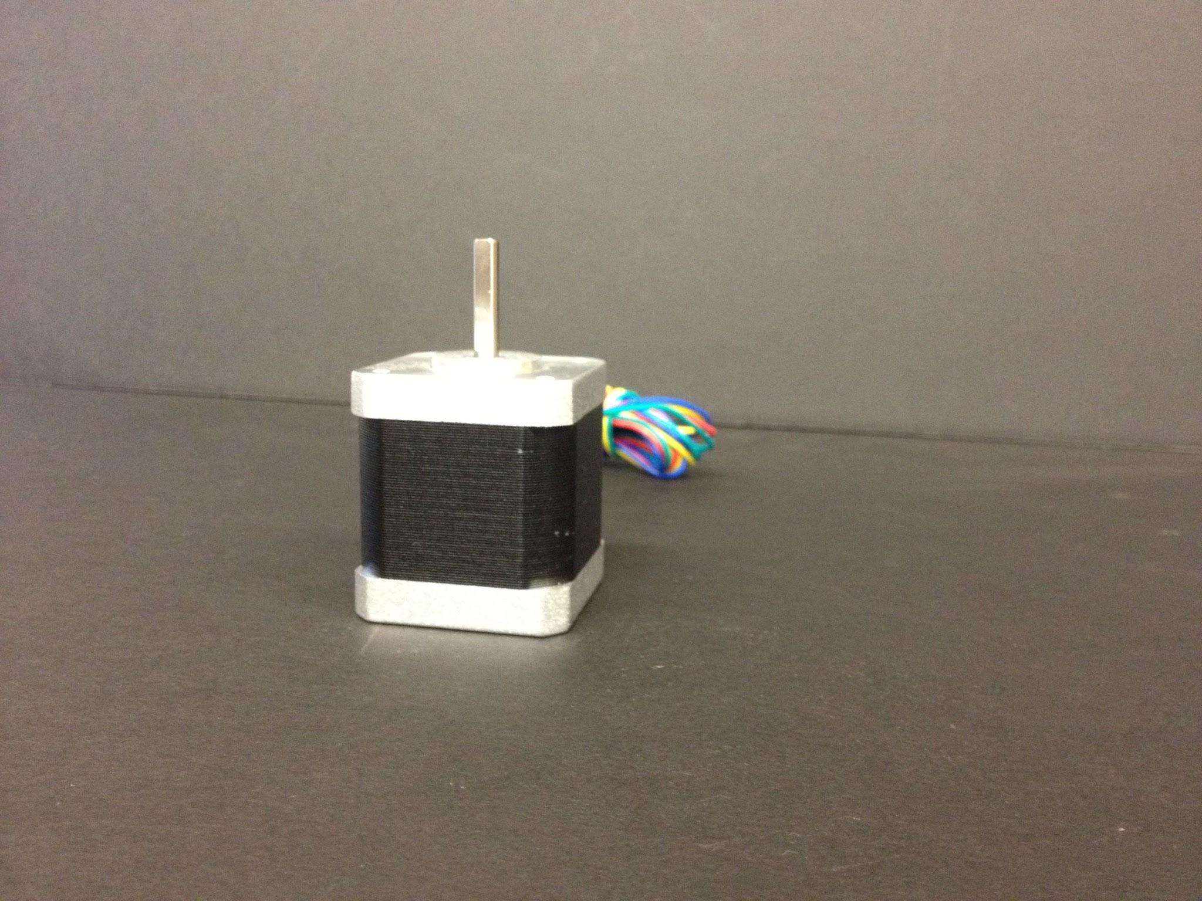

Electronics | Price Each | Part Number | Pcs.
Nema 17 Stepper Motor Z-Axis | 17.95 | MO-N17-48-22B-3X | 2pcs
NEMA 23 269 oz.in X-Axis | 17.95 | MO-N23-76-21B | 2pcs
NEMA 23 184 oz.in Y -Axis | 17.95 | KL23H251-28-4A | 1pcs

X-Axis Stepper Motors
2 x Nema 23 Stepper Motors 3.0 A, 1.9 N.m, 269 oz.in

Y-Axis Stepper Motor
1 x Nema 23 Stepper Motors 3.0 A, 1.9 N.m, 184 oz.in

Z-Axis Stepper Motors
2 x Nema 17 Stepper Motors 1.7 A, .59 N.m, 84 oz.in

Related Content
WorkHorse BOM
Igus Lead Screw
Linear Rails
WorkHorse Frame
WorkHorse Motors
WorkHorse Printer: Users Guide
Duet Wifi Setup
Duet 2 vs Duet 3
WorkHorse 3D Printer
Recommended Print Settings
3D Distributed

Firmware Files
config.g
Homeall.g
homex.g
Homey.g
Homez.g

Duet 3 Mainboard Setup
Duet3D YAT Commands
Reverse Motor Direction

Duet Wifi
Duet Wifi Setup

